Title of the presentation

Kodjo Antwui¹, Fela Kuti²
¹ Ghana Institute of Technology, Accra 0000, Ghana
²Lagos Institute of Science, Lagos 0001, Nigeria
Contact author: kuti.fela@lis.ng

Here is my abstract. Our article is about science in Africa [1]… Here is my abstract. Our article is about science in Africa… Here is my abstract. Our article is about science in Africa… Here is my abstract. Our article is about science in Africa… Here is my abstract. Our article is about science in Africa… Here is my abstract. Our article is about science in Africa… Here is my abstract. Our article is about science in Africa… Here is my abstract. Our article is about science in Africa… Here is my abstract. Our article is about science in Africa… Here is my abstract. Our article is about science in Africa…
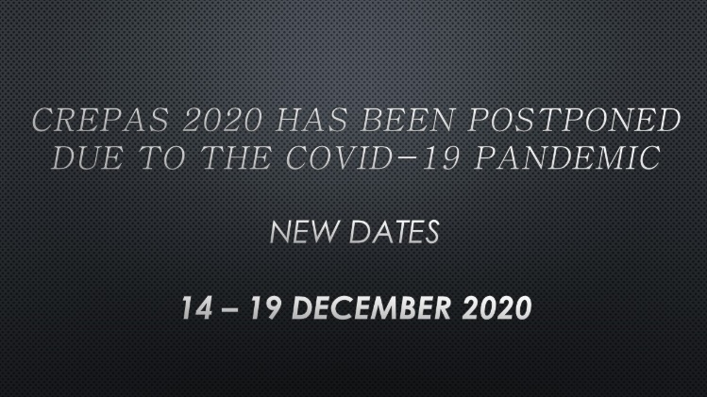
Figure 1: Regional Colloquium on Physics and its Applications
Here is my abstract. Our article is about science in Africa… Here is my abstract. Our article is about science in Africa… Here is my abstract. Our article is about science in Africa… Here is my abstract. Our article is about science in Africa… Here is my abstract. Our article is about science in Africa… Here is my abstract. Our article is about science in Africa… Here is my abstract. Our article is about science in Africa… Here is my abstract. Our article is about science in Africa… Here is my abstract. Our article is about science in Africa… Here is my abstract. Our article is about science in Africa…

References:
[1] | A. S. I. Network, “https://ascin.org/ascin/views/asn_conference_describ.php?rvv_cfr=2,” Juin 2020. [Online].

